Sick opens first Industry4.0-ready production facility

Waldkirch / Hanover, April 2019 – Since the middle of 2018, SICK has been manufacturing sensors in a digital plant at its Freiburg site featuring autonomous digital production and control processes. At the HANNOVER MESSE between April 1 and 5 (hall 9 / booth F18) Visitors take an exclusive look at the production of the 4.0 NOW Factory and learn about the advantages for companies of manufacturing according to industry 4.0.

With the fourth industrial revolution in full swing, it seems everybody is talking about Industry 4.0 (I 4.0) right now: The ability to network and control machines and processes using information and communication technologies is set to drastically change production processes as we know them. The production of the future may still be in its conceptual stages right now, but it is already very much a reality for SICK: In the production facility, the 4.0 NOW Factory, at the Freiburg site, robots and employees are working side by side to produce the new SICK sensors with twelve fully automated production technology modules, four manual workstations, and a hybrid workstation at their disposal.

Production reimagined
The cellular organization of the production process allows the modular usage sequence to vary as required. Material is supplied by means of automated guided carts (AGCs). All the workflows are managed by a high-performance software system developed in-house by SICK. This contains all information relating to each respective order, such as the product properties, quantity, and details on which production steps are required for each module. The system sends the information to the machines and receives constant feedback in return. All of the contributing elements – the sensors, machines, and people – are organized remotely, networked, and are in constant communication with each other.

Full flexibility: Quick and variable
Five product families are currently in production in the 4.0 NOW Factory, with the plan to increase this to 12. The system already features the necessary equipment to bring this plan to life, allowing SICK to implement and market new developments significantly quicker than ever before. The scope is available to cover more than 500,000 product variants. What’s more, the production processes can accommodate an unlimited variety of options, which allows a whole host of diverse and bespoke customer requirements to be taken into consideration. The factory is even capable of producing small quantities on demand – and at a cost similar to that of mass production.

Utilizing and strengthening the potential of I 4.0
SICK recognized the huge potential of Industry 4.0 very early on and intends to exploit it to its full potential at its Freiburg production facility. Underpinned by several years of preparation and a high level of investment, this major project sees SICK set to play a pioneering role once again. The company has even laid the foundations for the further development of its site: “We looked well into the future on this one. In fact, our plants are capable of manufacturing products that we haven’t even come up with yet,” explains Bernhard Müller.

In Freiburg, SICK has created the perfect conditions for working both with and on Industry 4.0: “With every day that goes by, we are collecting valuable knowledge when it comes to developing and improving this type of production even further,” explains Bernhard Müller. This not only relates to the processes in the digitally networked factory, but also to the ongoing optimization and marketing of their own products, solutions, and services. After all, sensors are the foundation of any Industry 4.0 scenario as data suppliers for the control systems. “We only install our own sensors and sensor systems in our plants. They have to be able to demonstrate what they are capable of here under real conditions. This provides us with important insights into how they work, shows us where we can still make improvements, and provides us with inspiration for new developments.”

Insight via live stream
At the HANNOVER MESSE, SICK will be offering an insight into its best-kept secret to date. Visitors to the trade stand will be able to take a look at the company’s glass production processes and experience I 4.0 live via live stream.
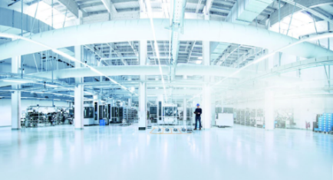
SICK_HalleHochdorf_cmyk
Since the middle of 2018, SICK has been manufacturing sensors in a networked plant at its Freiburg site featuring autonomous digital production and control processes.
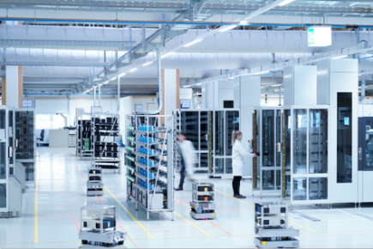
SICK_Hochdorf_Produktion_2_9AP6954
Driverless AGVs supply modules with material.

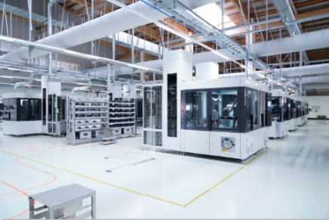
SICK_Hochdorf_Produktion_9AP7316
New sensors are produced with twelve fully automated assembly modules, four manual modules, and a hybrid module.

Contact
Melanie Jendro │PR manager │melanie.jendro@sick.de
+49 7681 202 4183 │+49 151 741 035 31

SICK is one of the world’s leading producers of sensors and sensor solutions for industrial applications. The company, which was founded in 1946 by Dr. Erwin Sick and has its headquarters in Waldkirch near Freiburg, Germany, is among the technology market leaders. With more than 50 subsidiaries and equity investments as well as many agencies, SICK has a agency all over the world. In the 2017 fiscal year, SICK had more than 8,809 employees worldwide and a group revenue of just under EUR 1.5 billion.
Additional information about SICK is available on the Internet at http://www.sick.com.

