Safe Robotics Area Protection: Collaboration without incident

Safety, flexibility, and productivity for human-robot interaction

Waldkirch, June 2018 – The Safe Robotics Area Protection safety system from SICK provides process-based protection for collaborative robot applications. It consists of a Flexi Soft safety controller and a safety laser scanner – either the space-saving S300 Mini Remote for shorter scanning ranges or the microScan3 Core for larger monitoring fields. Safe Robotics Area Protection satisfies the criteria of Performance Level PL d in accordance with EN ISO 13849-1. The safety system provides machine operators with unrestricted yet safe access to a robot’s working range at any time, by adapting the operating conditions to the position of the person. These adaptive perception capabilities prevent the risk of accidents occurring and simultaneously improve productivity by reducing downtimes and optimizing both the ergonomic and process aspects of the operator’s workflows. Safe Robotics Area Protection is a complete turnkey solution that is ready to use in no time at all: Thanks to its prefabricated and tested software function blocks, the safety system can be integrated with ease and fits seamlessly into the controllers of all standard industrial robots.
The migration capabilities of the system configuration, plus the option of adapting it in line with additional safety functions, make Safe Robotics Area Protection a future-proof safety system that enables flexible, autonomous machines and robots to adapt quickly and effortlessly to new production conditions, their safety requirements, and the protective field conditions that result from this.
Safety and productivity in harmony
Safe Robotics Area Protection intelligently combines the functions of a safety laser scanner – either the S300 Mini Remote or the microScan3 Core – with the possibilities offered by the Flexi Soft safety controller. This means that, based on the monitoring situation at the robot, differently dimensioned field sets can be equipped with warning and protective functions in the laser scanners and dynamically adapted in line with a detected worker position. Depending on how close the person is to the robot, the sensors cause the robot’s movement to either reduce or stop via the Flexi Soft safety controller – so that workpieces can be inserted or removed, for example. If the person then leaves the monitored area, the safety system automatically starts performing sequence monitoring. Provided that this monitoring satisfies the requirements for operating the robot safely, the robot is first started up at a reduced speed and then returns to its original working speed once all the warning and protective fields are free again. This means that the worker remains constantly protected against hazardous movements whenever they enter the robot’s working range. At the same time, the automated restart reduces downtimes once a worker leaves the hazardous area, and also optimizes the worker’s processes – laying the foundations for machines and industrial robots to be more productive.
Versatile, integration-friendly, and future-proof
The Safe Robotics Area Protection safety system’s versatility is a standout feature. It makes it possible to factor in new working situations and conditions, and take account of non-safe automation functions and safety-related functions being carried out simultaneously – in the way that they have been prefabricated and tested. In turn, this allows the safety system to be integrated into the most commonly used varieties of robot controllers with minimum integration work, using the function block provided. If other safety devices are added or additional safety functions become necessary during operation, these can be integrated with ease later on – making the Safe Robotics Area Protection safety system even more of a sound, future-proof investment.
Collaboration on an equal footing: SICK sensor solutions for robotics
Industrial robotics holds one of the keys to establishing automation concepts that are fit for the future – and all the more so if they are able to provide an environment in which humans and robots can work increasingly as colleagues in a range of different scenarios. In these applications, it is the sensors that give robots the ability to perceive their environment accurately – and it is this that enables collaboration on an equal footing. With Robot Vision, Safe Robotics, End-of-Arm Tooling, and Position Feedback, SICK provides the right solutions for every challenge presented by robotics.

The optical and image-based systems in the Robot Vision portfolio provide the robot’s eyes, allowing it to detect humans and materials. Visual robot guidance in 2D and 3D makes it possible to deliver highly flexible and productive automation solutions in production, mounting, joining, and handling processes – such as those found in automated glue bead application, weld seam inspection, and bin-picking applications.

Safe Robotics from SICK provides solutions that are designed to keep humans safe and ensure maximum productivity at the same time. They include all the measures that turn the sensitive area close to the robot into a safe workspace. Adaptive perception of the environment takes place with the aid of intelligent, rugged, and reliable sensors and safe systems. These enable unimpaired and safe human intervention into the robot’s working range – allowing people to work closely alongside robots and keeping them safe in the process.

With End-of-Arm Tooling, SICK offers sophisticated, intelligent sensors for grippers and robotics tools, designed to keep robots as sensitive as possible and enabling them to work with fingertip precision. The portfolio covers all gripper arm applications and the feed systems associated with them.

In Position Feedback solutions from SICK, the motor feedback systems integrated into the drives deliver data on speed and position as well as on the status of the drive. As a result, these smart motor sensors create the sensory foundation for all robot movements.
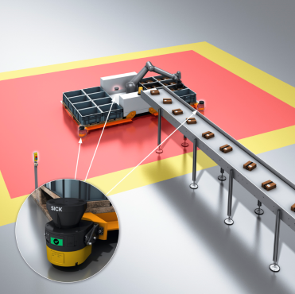
Image: SICK_safe_robotics_area_protection_0078589
This means that, based on the monitoring situation at the robot, differently dimensioned field sets can be equipped with warning and protective functions in the laser scanners and dynamically adapted in line with a detected worker position.

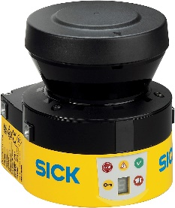
Image: SICK_S300mini_remote_0051076 & SICK_microscan3_core_0073893
Safe Robotics Area Protection intelligently combines the functions of a safety laser scanner – either the S300 Mini Remote or the microScan3 Core – with the possibilities offered by the Flexi Soft safety controller.

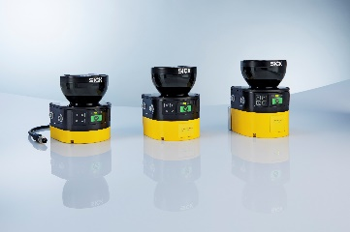

SICK is one of the world’s leading producers of sensors and sensor solutions for industrial applications. Founded in 1946 by Dr.-Ing. e. h. Erwin Sick, the company with headquarters in Waldkirch im Breisgau near Freiburg ranks among the technological market leaders. With more than 50 subsidiaries and equity investments as well as numerous agencies, SICK maintains a presence around the globe. In the fiscal year 2017, SICK had almost 9,000 employees worldwide and achieved group sales of around EUR 1.5 billion.
Additional information about SICK is available on the Internet at http://www.sick.com or by phone on +49 (0) 7681 202 4183.

