Blue meets yellow – a green light for safe magazine filling

Functional safety systems – Safeguard Detector Core

Waldkirch, September 2015 – When it comes to material transportation in particular (of flat carton blanks, for example), there is a danger of the operator reaching into the magazine to add more material while the machine is running. The Safeguard Detector from SICK is a certified, all-round safety package designed to avoid potential injuries.
The packaging material in the conveyor magazine of a packaging machine acts as a physical guard during operation. If there is sufficient material in the magazine, then reaching into the mechanics while the machine is running is prevented. This protection is gone as soon as there is no more material in the magazine. The moving process mechanics in the packaging machine are left exposed and pose a serious risk of injury. Safeguard Detector Core comprises the Flexi Soft safety controller and the MultiPulse MultiTask photoelectric sensor, which operates in the same way as a photoelectric proximity sensor. This safety package avoids the risk of injury from reaching into the empty conveyor magazine.
Flexible and compact structure
Two MultiPulse MultiTask photoelectric sensors monitor the packaging machine magazine. The modular Flexi Soft safety controller evaluates the sensor signals using certified function blocks.
Modular and adaptable
The sensors mounted on the side monitor the stack of cartons. This result in new freedom for the machine design: format adjustment of the carton feed can be implemented more simply.
An intelligent safety solution from a single source
In one package SICK offers intelligent analysis using Flexi Soft, in addition to the pulsed sensors. Along with the reliable and proven components, machine developers and system operators can also rely on the safety assessment of the subsystem. The carton magazine monitoring – as soon as available – is certified with PLd according to EN ISO 13849.
Functional, systematic safety
The self-testing process, which conforms to functional safety requirements, can only be ensured in the system of all components. The two MultiPulse devices provide the required dual-channel, pulsed signals, which are analyzed using the Flexi Soft safety controller.
Figure: Safeguard_Detector.jpg
Safeguard Detector – functional safety systems

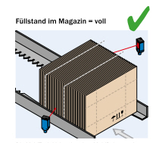

The MultiPulse MultiTask photoelectric sensors are installed at a distance of between 30 mm and 100 mm from the material.

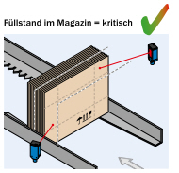

If the filling level in the magazine reaches a critical limit within the optical sensor detection zone, then this creates a dangerous state which is monitored for safety.

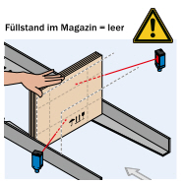

As soon as the material falls below the minimum filling level, the sensors detect that material is missing. The safety function can no longer be guaranteed once the magazine is full. This leads to a safety shutdown in the system.

SICK is one of the world’s leading producers of sensors and sensor solutions for industrial applications. Founded in 1946 by Dr.-Ing. e. h. Erwin Sick, the company with headquarters in Waldkirch im Breisgau near Freiburg ranks among the technological market leaders. With more than 50 subsidiaries and equity investments as well as numerous representative offices, SICK maintains a presence around the globe. In the 2014 fiscal year, SICK had about 7,000 employees worldwide and achieved Group sales of EUR 1,099.8 million.
Further information on SICK is available on the Internet at http://www.sick.com or at +49 7681 202-3148.

