Dr. Niels Syassen

Member of the Executive Board
Technology & Digitalization Portfolio

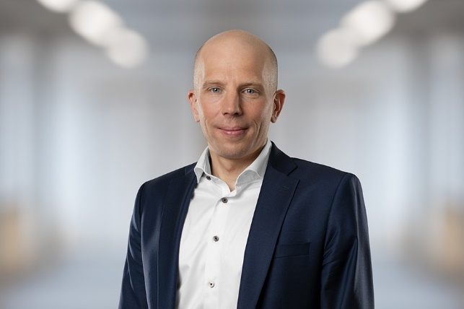
From 1 October 2021, Dr. Niels Syassen will be the Executive Board member with responsibility for SICK AG’s Technology & Digitalization portfolio. He joined the company in 2017 and, as a member of the Management Board, has been responsible for innovations in the gas and particle analysis solutions unit since 2018. Before this, he was active in various management functions in product development for sensors at Bosch in the Automotive Electronics division and at Dräger in their Safety Technology division.
Dr. Niels Syassen was born in Düsseldorf in 1977. He studied physics, specializing in lasers, optics and semiconductors at the Technical University of Munich and at Imperial College in London. He completed his doctorate at the Max Planck Institute for Quantum Optics in 2008.

SICK is one of the world’s leading suppliers of solutions for industrial sensor-based applications. The company, founded in 1946 by Dr. Erwin Sick and based in Waldkirch-im-Breisgau near Freiburg, is a technology and market leader with a global presence – with more than 50 subsidiaries and associated companies, as well as numerous sales offices. SICK achieved Group sales of about EUR 1.7 bn. during the 2020 fiscal year with more than 10,000 employees worldwide. Further information on SICK is available at www.sick.com

