Feng Jiao

Member of the Executive Board

Portfolio: Sales & Service

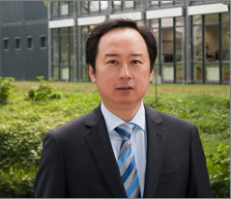
Feng Jiao has been appointed to the Executive Board with responsibility for the Sales & Service portfolio with effect from 1 January 2021. He joined the company in 2014 and, as Managing Director of SICK China Co., Ltd., was responsible for the Group’s sales activities on the Chinese market. At Siemens, from 1994, he was active in leading sales positions in China and Canada. He took over sales management for the Asia-Pacific region at the Data-Linc Group in 2001, before moving to the technology company Harting in 2007 as Director Business Development Greater China.
Feng Jiao was born in Beijing, China in 1969 and completed his studies in Engineering at the Beijing Institute of Technology in 1992. He has the Canadian citizenship.
SICK is one of the world’s leading producers of sensor-based solutions for industrial applications. The company, founded by Dr. Erwin Sick in 1946 and based in Waldkirch-im-Breisgau near Freiburg, is a technology and market leader. It has a worldwide presence with more than 50 subsidiaries and associated companies, as well as numerous sales offices. SICK achieved Group sales of about EUR 1.8 bn. during the 2019 fiscal year with almost 10,000 employees worldwide. More information on SICK is available at http://www.sick.com.

