W4F miniature photoelectric sensor: performance to perfection

Waldkirch, February 2021 – SICK is launching its latest generation miniature photoelectric sensor, the W4F, on the market. A new ASIC platform delivers numerous performance advantages to this product family. For example, these sensors are able to detect even jet black, highly reflective, flat or transparent objects with the utmost reliability. The W4F can also provide distance information, e.g., the height of objects, and thereby identify process errors. Initial users have confirmed that the photoelectric sensors have the best ambient light and sunlight suppression on the market as well as maximum immunity to all known sources of optical interference. Furthermore, the Blue Pilot operating concept combined with the innovative monitoring options make configuring and monitoring the sensors easier than ever. This saves time during commissioning. IO-Link and new smart functions for sensor monitoring and diagnostics create the link to the digitalized machine and application world. In summary this means: maximum performance in the smallest installation space, reliable switching behavior, and guaranteed process and future certainty – even in the new applications that open up for the W4F.
The next generation W4F with its highly rugged Vistal® plastic housing offers sensor functions and performance characteristics that were previously only available in the larger W16 and W26 product families from SICK. Their Blue Pilot operating concept, for example, has been implemented in the W4F as well. The next generation of miniature photoelectric sensors therefore offer the same tried-and-proven look and feel – a consistency that makes operating and commissioning sensors significantly easier for users.
New ASIC delivers increased performance
Up to 47 percent greater working distance than the predecessor product family, photoelectric proximity sensors with 38 percent less black/white shift between the object and background – with the W4F, SICK has achieved a significant performance boost for opto-electronic miniature sensors. This applies also to the improved, active detection of sources of optical interference in the vicinity of the machine environment, and the suppression of this interference. The high level of immunity to interference is achieved thanks to the integration, for the first time ever for this type of sensor, of an additional diffuse LED. The background suppression of the W4F – which is significantly superior to that of other makes in the market – guarantees a continuous machine operation with no interference from the surroundings.
The foundation for this performance is the development of a new ASIC that enables both the two light-intensive pin-point emitter LEDs and the diffuse LED to be operated concurrently without any appreciable heating of the sensor. This avoids the risk of a temperature-related failure. The ASIC also directly digitizes the photocurrents of the reflected light at each pixel of the multipixel receiver. This enables the sensor to achieve not only a very high sensitivity but also a long sensing range and reliable detection behavior even for poorly reflecting object surfaces. In addition, the digital filters of the ASIC guarantee the best ambient light suppression on the market today. This ensures reliable processes. Additional process and diagnostics data as well as supplementary operation-related information such as temperatures and operating hours can also be collected. The W4F therefore offers probably the most features and functional reliability on the market. Users benefit from the continuous and fault-free availability of the sensors as well as failure-free operation of their machines.
Optical Standard, Optical Experts – the right sensor solution for any task
The next generation W4F portfolio comprises two sensor business field: Optical Standard and Optical Experts. The sensors in the Optical Standard business field – a through-beam photoelectric sensor and a photoelectric retro-reflective sensor, each with a long sensing range as well as two photoelectric proximity sensors with background suppression – have proven themselves in the field as space-saving and high performance allrounders for object detection. One of the photoelectric proximity sensors offers an exceptionally concentrated light beam and point geometry (narrow beam). This enables the sensor to also detect jet black objects with a remission of less than one percent.
For especially challenging situations, users can trust in the Optical Experts. These SICK sensors have been designed for specific applications. With the help of its laser-like light spot, its V-optics, and its specially tailored optics design, the V-Optics variant can reliably detect even the most reflective or transparent objects such as wafers or displays. To precisely detect thin objects or labels, SICK offers a photoelectric proximity sensor with two LEDs and a high performance foreground suppression. A photoelectric proximity sensor with two line-shaped light spots (DoubleLine) ensures a continuous switching signal even for objects with holes, drillings or recesses. Photoelectric proximity sensors that output distance values and feature a MultiSwitch functionality – i.e., with two switching points – monitor the correct mounting of components in assembly processes. In food packaging applications they can distinguish between upright and horizontal packaging, report high and low fill levels, or monitor the diameter of film, packaging material, or label rolls.
For more information on the next generation W4F, visit www.sick.com/W4F.
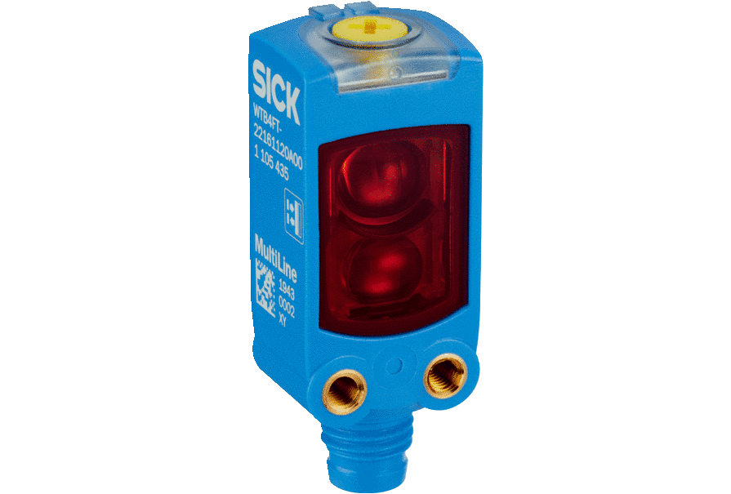
The W4F miniature photoelectric sensor from SICK – the right sensor solution for any task.

Contact
Melanie Jendro │PR manager │melanie.jendro@sick.de
+49 7681 202 4183 │+49 151 741 035 31

SICK is one of the world’s leading solutions providers for sensor-based applications in the industrial sector. Founded in 1946 by Dr.-Ing. e. h. Erwin Sick, the company with headquarters in Waldkirch im Breisgau near Freiburg ranks among the technological market leaders. With more than 50 subsidiaries and equity investments as well as numerous agencies, SICK maintains a presence around the globe. In the 2019 fiscal year, SICK had more than 10,000 employees worldwide and a group revenue of around EUR 1.8 billion. Additional information about SICK is available on the Internet at http://www.sick.com

