SICK launches EventCam for troubleshooting

Waldkirch, July 2019 – The new EventCam from SICK brings clarity rather than confusion when unexplained gripping, handling or positioning problems, unreproducible installation errors, or machine downtimes arise. The industrial-grade 2D camera has been specifically designed for the detection and analysis of sporadic errors in industrial processes. It can be integrated with great flexibility into stationary and mobile applications, is network capable, and delivers single frames and video sequences in ultra-high image quality for detailed error analyses.
The optics, illumination, electronics, and ring memory of the new EventCam from SICK are enclosed in a compact and rugged IP65 housing made from cast aluminum. The housing provides numerous mountings options that allow the camera to be installed in different positions, and these positions can be changed very quickly and flexibly. Configuring the camera is very simple: the resolution, output format, and trigger signal can be set with just a few clicks in SICK’s browser-based SOPAS Air software.
Event sequences rather than continuous streaming ensures targeted and fast error analysis
The EventCam has been specifically designed for fast and targeted error analysis. A connected automation system or sensor reports that an error has occurred in the process via the trigger input in the camera itself. The camera then begins storing single frames and video sequences. Up to 240 seconds before, and up to 100 seconds after an event can be stored in the internal ring memory – either in full HD or, for example in high speed processes, at the lower SVGA resolution. In contrast to the time-consuming process of searching for an event in continuous video material, as provided for example by a GoPro or other streaming camera, the EventCam enables a targeted root cause analysis to be performed in just a few seconds or minutes. It is not necessary, either, to first upload the images and film sequences from the memory card – they can be accessed over the network in realtime at 100 Mbit/s via FTP and the Ethernet interface on the EventCam.
Efficient support tool, including when commissioning
The EventCam not only enables a fast and detailed retracing of events in running machines and plants, but is also very useful when commissioning or optimizing them. The ability to quickly analyze errors in an unsupervised test run or a multi-hour or multi-day continuous test reduces the effort required to locate errors and therefore the time and costs associated with machine setup. The high mounting flexibility and simple configuration of the EventCam enables it to be used in a wide variety of machines, setup processes and tasks.
Currently available in two variants for different working distances
The EventCam is currently available in two identically designed variants. The version with a 0.4 m to 0.6 m working distance is primarily intended for stationary applications in machines or compact assembly or pick-and-place robots. The camera with a 0.8 m to 6 m working distance is designed for use in larger robots, handling gantries or machines.

Caption

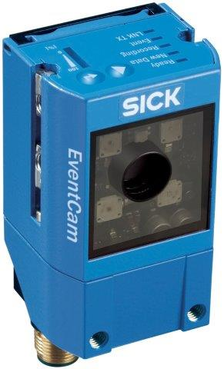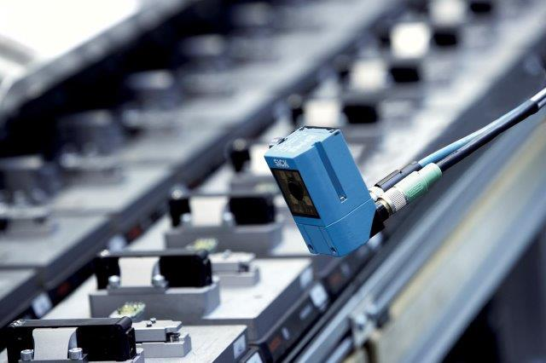
A phenomenal solution for unexplained phenomena in industrial processes: the EventCam from SICK is an industrial-grade 2D camera for the targeted detection and analysis of sporadic errors.

Contact
Melanie Jendro │PR manager │melanie.jendro@sick.de
+49 7681 202 4183 │+49 151 741 035 31

SICK is one of the world’s leading producers of sensors and sensor solutions for industrial applications. Founded in 1946 by Dr.-Ing. e. h. Erwin Sick, the company with headquarters in Waldkirch im Breisgau near Freiburg ranks among the technological market leaders. With more than 50 subsidiaries and equity investments as well as numerous agencies, SICK maintains a presence around the globe. In the 2018 fiscal year, SICK had almost 10,000 employees worldwide and a group revenue of around EUR 1.6 billion.
Additional information about SICK is available on the Internet at http://www.sick.com or by phone on +49 (0) 7681 202 4183.

